**HTML Table Exercise**

Organizing Student data using HTML table. Please ensure you read the codes and comments carefully. We’ll be using the element again, you can refer back to the beginning of this post to get the meaning of each tags

[html]

<h1>Student Records</h1>  
<table border=”1″>  
<thead>  
<tr> <!– Heading row –>  
<th>No.</th>  <!– First Column data –>  
<th>Image.</th>  <!– Second Column data –>  
<th>First Name</th> <!– Second Column data –>  
<th>Last Name</th> <!– Third Column data –>  
<th>Age</th> <!– Fourth Column data –>  
<th>Hubby</th> <!– Fourth Column data –>  
</tr>  
</thead>  
<tbody>  
<tr> <!– First row –>  
<td>1</td>  
<td><img src=”https://images.vexels.com/media/users/3/145743/isolated/preview/b46f965c51e1ce30b5cb485b6c9c4e03-homem-m-o-cruzou-a-ilustra–o-by-vexels.png” height=”100″ width=”100″ alt=””></td>  
<td>James</td>  
<td>Frosty</td>  
<td>25</td>  
<td><a href=”https://google.com”>Swimming</a></td>  
</tr>  
<tr> <!– Second row –>  
<td>2</td>  
<td><img src=”https://png.pngtree.com/element_origin_min_pic/17/01/01/a8c6df6c15a1ee8985ddc5d371296d2f.jpg” height=”100″ width=”100″ alt=””></td>  
<td>Anna</td>  
<td>Bayo</td>  
<td>23</td>  
<td><a href=”https://google.com”>Cooking</a> </td>  
</tr>  
<tr> <!– Third row –>  
<td>3</td>  
<td><img src=”https://png.pngtree.com/element_origin_min_pic/17/03/19/8be63cc1c4d6542e54887087a634dadd.jpg” height=”100″ width=”100″ alt=””></td>  
<td>James</td>  
<td>Lartey</td>  
<td>22</td>  
<td><a href=”https://google.com”>Rapping</a> </td>  
</tr>  
</tbody>  
</table>

[/html]

OUTPUT:[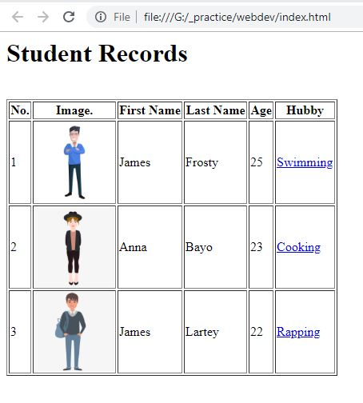](https://vincenttechblog.com/working-with-tables-in-html-with-exercise-lesson-1-5/table_example/)